Description of Current Situation:
Over the first 12–36 months, order backlog increases significantly (from 90 to ~438), while order fill rate increases slightly (~3.9%). This indicates production capacity is not scaling fast enough to meet rising demand. As a result:
- Pressure on Production increases in tandem with the backlog.
- Percentage Capacity Utilisation increases (approaches 100%), but it lags behind due to a conservative utilisation curve.
- Actual Delivery Delay increases by ~10%—driven by the growing backlog and stable fill rate.
- Average Order Fill Rate does increase, but only marginally due to smoothing and system inertia.
Beyond 36 months, backlog growth outpaces capacity growth. The model suggests:
- Delivery delays become chronic, with fulfilment lagging behind orders.
- The production system becomes a bottleneck.
- The lag between capacity decisions and arrival (12 months) exacerbates this issue.

Short-Term Policy: Optimise Utilisation
The model should be revised so that the percentage utilisation increases more sharply in response to the backlog-to-capacity ratio, reaching full utilisation when the ratio exceeds 1. In practice, this can be achieved by implementing overtime shifts, improving production scheduling, and accelerating staff training. These measures aim to maximise the number of orders fulfilled using existing capacity while the business prepares for future expansion.

Long-Term Policy: Aggressive Capacity Expansion
The model should be adjusted by increasing the capacity expansion fraction from 0.15 to 0.25 and eliminating the delivery delay bias by reducing it from 0.3 to 0. In real-world terms, this means removing overly cautious limits on capacity growth and making investment decisions that are more responsive to actual demand. These changes are intended to support continuous expansion, ultimately helping to reduce both backlog and delivery delays over the long term.

Scenario 1: Optimised Utilisation (Short-Term)
The utilisation curve should be modified to reach full (100%) utilisation when the backlog-to-capacity ratio is at or above 1, with a steeper increase in utilisation between ratios of 0.5 and 1.0. As a result, the order fill rate is expected to improve quickly by around 5–6%. This adjustment should help slow the growth of the backlog or stabilise it altogether, while actual delivery delays are likely to level off or rise less sharply. Although production pressure will remain elevated, it is expected to become more stable.
Increased utilisation reduces backlog growth temporarily and improves short-term fulfilment, but strain on capacity persists, risking longer-term delivery problems.

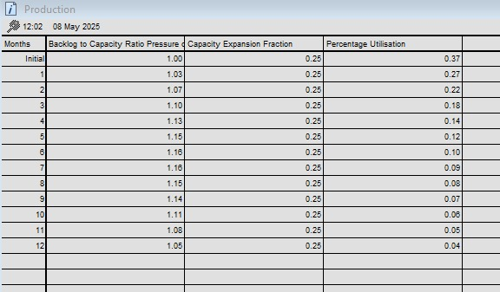
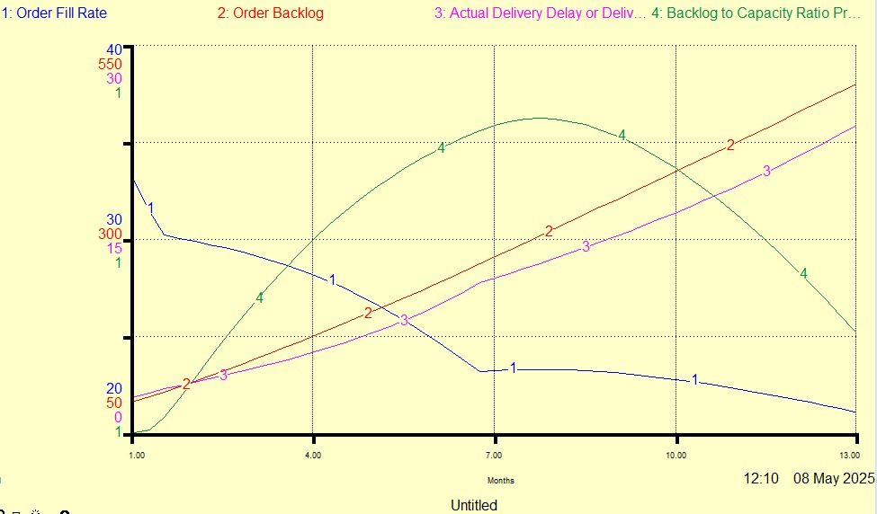

Scenario 2: Expansion Strategy (Long-Term)
The capacity expansion fraction should be increased from 0.15 to 0.25, and the delivery delay bias should be reduced from 0.3 to 0. These changes will result in faster capacity growth, with the order fill rate showing a steady increase after a 12-month lag. The order backlog is expected to decline after approximately 18 to 24 months, accompanied by a reduction in actual delivery delays. Over time, this will also ease the pressure on production.
Capacity expands adequately to absorb rising demand. Backlog reduces, delays improve, and production stabilises by month 24+. This supports sustainable growth.

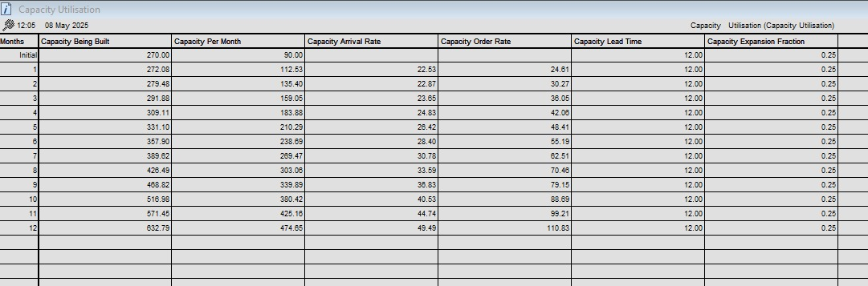
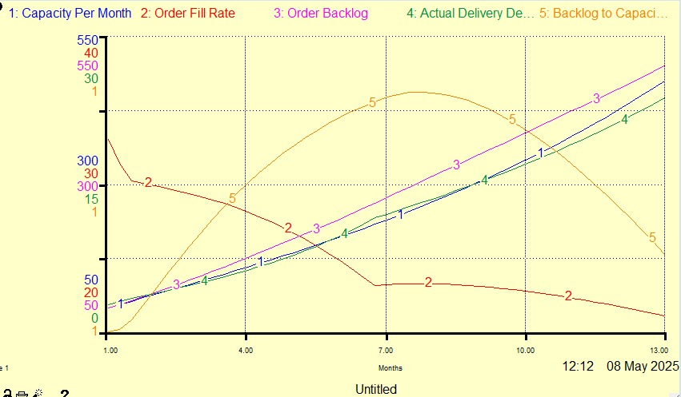

Short-Term Recommendation
To enhance responsiveness to production pressure, utilisation should be increased by introducing shift flexibility, hiring temporary staff, and applying lean management tools. These measures aim to prevent the backlog from escalating during short-term spikes in demand. As a result, order fulfilment is expected to improve, and immediate delivery delays should be reduced.

Long-Term Recommendation
The expansion fraction should be increased to 25% and the delay bias eliminated by setting it to zero. This can be achieved by giving the production team the authority to recommend capacity expansion based on real-time backlog and delivery delay data. The existing conservative approach has led to long-term inefficiencies, whereas this adjustment would help stabilise the backlog, improve delivery times, and make the system more scalable for future growth.

